06.03 Line Maintenance Oversight
Process Design & AMOS Configuration Document
Purpose
This Process Design document is provided to Key-Users to record their key decisions regarding the AMOS Process design and the required AMOS configuration.
It is updated throughout the Project Definition Phase and used as the baseline for the Final Acceptance prior to Go-Live
Revision
Author, Name | Date | Notes
FDEL | 30-05-2024 | First Version
BENX | 18.11.2024 | Process Flow updated
MTAR | 03.06.2025 | Process Flow updated

Contents
1. Process Overview & Objectives 3
2. Regulatory References 3
3. Definitions & Glossary 3
4. Process Tasks 4
5. Process Dependencies 4
6. Process Flow 5
7. Process Design Questions 6
8. Data (Source) Mapping 7
9. Other Software Used 7
10. AMOS Configuration 7
a. Basic Data 7
b. Parameters 8
c. Workflows 8
d. Scheduled Tasks 9
e. API’s & Interfaces 9
11. Annex – Additional Info 9

Process Overview & Objectives

Process General Description:
This process describes how Line Maintenance shift leaders keep control of the works execution stream, going through planning phase, capacity management, resource assignment, leading to the work execution and aircraft release.
The planning phase depends on the on the ownership of aircrafts (managed or non-managed in AMOS) and could be completely manual or integrated with the Planning Automation module.
It’s fundamental to have visibility of ground times in the system and this can be achieved by using dedicated interfaces:
- Flight import (form managed aircrafts)
- Ground time import (for non-managed aircraft)
Shift Plans need to be implemented in AMOS in order to manage capacity and resource assignment.

Main Process Objective (Outputs & Outcomes):
The main purpose of this Line Maintenance Oversight is to have a complete control of the line maintenance activities from planning to execution phase, optimizing the workload distribution and providing tools to improve quality and speed of processes in order to reduce time and increase operational readiness.

Regulatory References

The following regulatory references are relevant for this process:
- EASA annex II Part-145 AMC1 145.A.70 (a) Part L2
- FAA AC_145-9A Chapter 5

Definitions & Glossary

Key-Words | Explanation
Groundtime | Timeframe between arrival and departure of an aircraft
Reservation | Assignment of staff to a task
Info Task | Job instruction not controlled by CAMO and can be associated to a specific flight rather than with the aircraft itself.

Process Tasks

Main Process Task / Actions / Activities:
Note: It is strictly recommended to always have a work package for maintenance activities both scheduled (Checks, Rotable Requirements, Replacement Events, Documents, Single Running Taskcards) and unscheduled events (pilot reports, cabin defects or findings created by maintenance). Only with a work package which have defined station and planned date/time, all integrated processes like material planning, resource management and capacity planning will work properly. In addition, the work package will ensure authority requirement as this define a clear work scope for the MRO and will enable to create a traceable certificate of release to service including all related paperwork.
The following actions are performed in this Business Process:
- Create a Work package (could be for managed or non-managed aircraft).
In case of using Planning Automation, set up of APN 2951 is needed.
  - Define A/Cs, stations and timeframe for system ground time generation.
  - Define Work package generation rules
  - Set-up auto-assignment rules for Checks, SRTs, Workorders, CRs, Info Tasks
  - Set-up a clean-up rule
- Assess capacity comparing the workload with staff availability (this could be done in APN 711: Resource Overview)
- In Line Maintenance Manager (APN:2950):
  - Filter station/fleet/staff to have an oversight of flights/ground times/work packages
  - Create reservations assigning staff to workload (this can be done at work package/workorder/work step level)
  - Create and assign non-technical tasks if needed (info tasks)
  - It’s possible to assign multiple staff to the same work package or vice versa.
  - Vehicles can be assigned to staff
  - Every reservation is reflected in real time on AMOS Mobile EXEC so every technician can accept or refuse, perform live booking, communicate when the job is completed.
  - The system will show in real time
    - Flight info: arrival/departure flight, ground time duration,
    - The progress of work package based on the number of closed workorders/work step
    - The coverage of the work package (comparing the estimated mhrs needed with the amount of technicians assigned)
    - Utilization of each technician to optimize reservations

Process Dependencies

The following process dependencies are identified for this process:
- 07.01 – Shift Planning: Staff availability and attendance are reflected on APN 2950
- 03.02 – Workpackage generation: creation of the workload to be managed in Line Maintenance
- 05.02 – Pilot Reports: Parts of unscheduled maintenance affecting the workload
- 05.03 – Cabin defects: Parts of unscheduled maintenance affecting the workload
- 06.02 – Delays & Event tracking: Parts of unscheduled maintenance affecting the workload
- 08.02 – Performing Maintenance: execution of the maintenance events

Process Flow

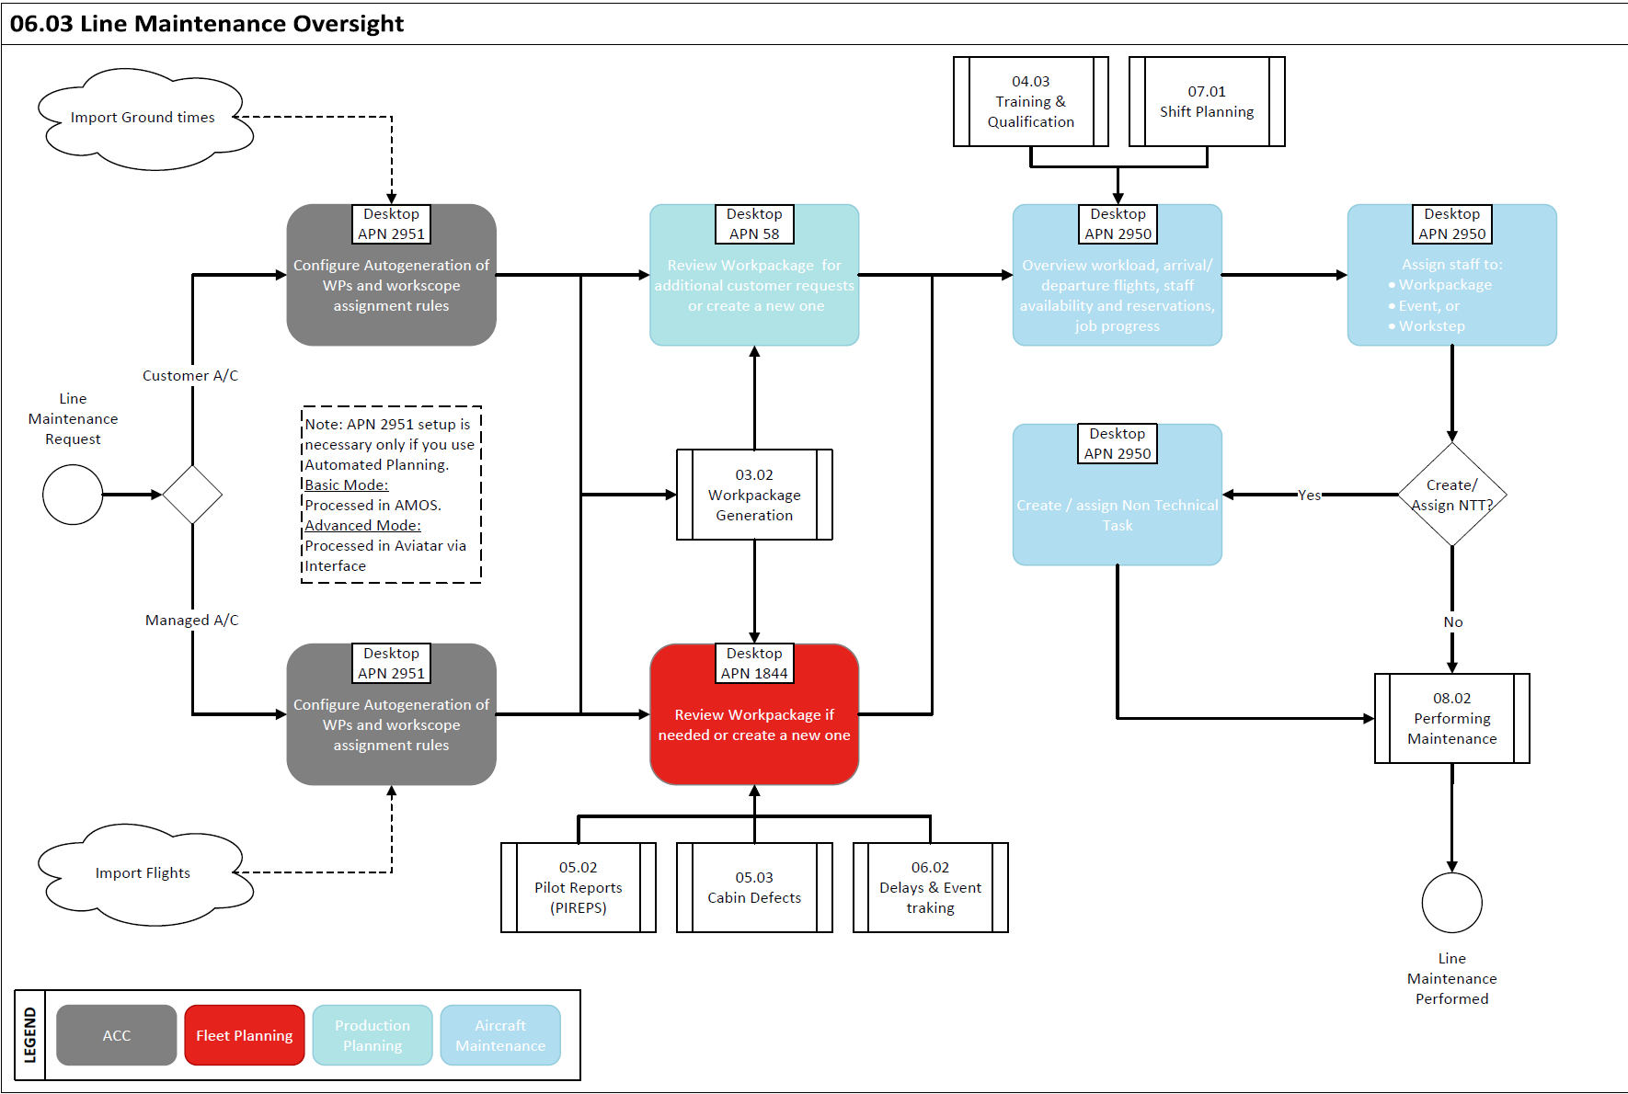

Process Design Questions

# | Question | Answer
1 | Do you perform line maintenance for customers?
2 | Which is your Flight Ops system? How many days in advance tail assignment is done?
3 | Do you use/want to implement AMOS Mobile Exec?
4 | Which kind of Technical Logbook is used - hardcopy or electronic?
5 | Who is responsible to build work packages for line maintenance? CAMO Short Term Planning? Production planning? (in case of Customer A/C)
6 | Who is in charge of assigning staff to the aircrafts? Shift leaders? Line Production Planning?
7 | Do you have shift plans defined in your system?
8 | How do you manage Daily checks?
9 | Do you use taskcards for preflight / transit checks? Or just create an entry on the ATL?
10 | Do you want to use Info task to manage assignment of non-technical tasks to staff? (non-CAMO related tasks, for example stairs removal, GPU, etc.)

Data (Source) Mapping

Data Sources | Description | Volume / Manual / Automatic / Static / Dynamic
-Nil-

Other Software Used

Other Softwares | Used by: | Description
-Nil-

AMOS Configuration

Basic Data

Basic Data Table | Notes
Groundtime Extension Reasons | This table is used to specify the reason why a Workpackage can be extended. When extending a Workpackage it is mandatory to choose from one of these Codes.
Workpackage Priority Codes | To define the priorities of your workpackages
Priority | All workorders have a priority. The pre-defined priorities range is between 1 to 5. Customizable special priorities are defined in this table.
Vehicles | This table stands to define a list of Vehicles than can be assigned to groups/staff

Parameters

Parameter Code | Parameter Name | Notes
1880 | Time Panel Configuration | To better visualise the boundaries of time intervals in AMOS time panels, set the String value to Y; this draws a vertical dark grey line over the lower and upper boundary of the defined time range | Y
1404 | Use Shiftplan in Planning Modules | With this parameter you can control if the shiftplan taken from the AMOS shiftplanning modules should be used to calculate the availability of human resources or not.  If set to "Y" you will see the shiftplan in ResourceManagement module for all human resources. If you don`t use the AMOS shiftplanning modules you should set this parameter to "N". | Y
1894 | Maintenance Planning Automation Logic (BETA) | This parameter allows you to define which logic is used by the maintenance planning automation process | 0

Workflows

Workflow Number | Workflow Name | Notes
457 | Line Maintenance Info.Messages | This workflow is triggered from Line Maintenance Manager to notify mechanics.
460 | Work Assignment / De-assignment Notification | This workflow is triggered to notify mechanics when a workload is assigned or de-assigned.
479 | Before creating, updating or deleting a Ground Time | This workflow is triggered right before a Ground Time entry is either created, updated or deleted
480 | After creating, updating or deleting a Ground Time | This workflow is triggered right after a Ground Time entry is either created, updated or deleted
88 | Staff Request | This workflow is triggered, when a Staff Request is opened for an employee
89 | Staff request review | This workflow is triggered when a staff request is reviewed for an employee
460 | Work Assignment/De-assignment Notification | This workflow is triggered to notify mechanics when a workload is assigned or de-assigned
648 | After creating, updating or deleting a Info Task | This workflow is triggered to notify mechanics when an Info Task was created, changed or deleted. It can be used if the optional licence to create Info Task is owned (4156).

Scheduled Tasks

Scheduled Task Reference | Frequency | Notes
LineMaintenanceAutomaticGenerationTask | Same of Flight import task

API’s & Interfaces

Reference | Direction | Trigger | Frequency
IMPORT AIMS FUTURE FLIGHTS  IMPORT NETLINE LEG DETAIL  TRANSFER FUTURE FLIGHTS | IMPORT | Flight schedule change | Depends on the fleet size and network stability

Annex – Additional Info

-Nil-

